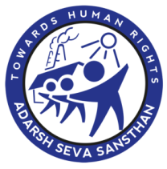

ANNUAL REPORT: 2020-21

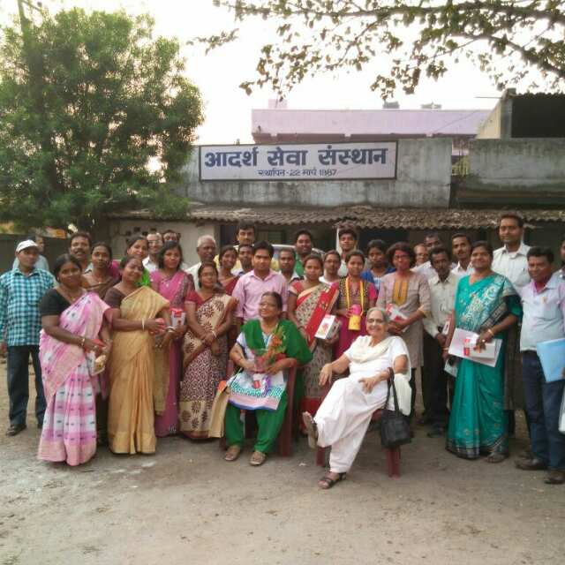

ADARSH SEVA SANSTHAN (ASES)
Jamshedpur – 831011.Dist: East Singhbhum,Jharkhand
0657-2314098
ases.mailbox@gmail.com
www.asesjsr.org

PREFACE

Dear Friends,

At the onset of the year 2020 and later, whole world came across a new virus which cause Severe Acute Respiratory Syndrome Corona virus 2(SARS- COV-2), which was later named as COVID-19. In the days to come this pandemic will gradually spread across the globe, as per experts. Together we can and will fight this pandemic, so let’s join hands together and support each other as much as possible with the available resources
Our motto“जिनकामुद्दाउनकीलड़ाई,जिनकीलड़ाईउनकीअगुवाई”itself depicts that we work for and with community by strengthening and empowering them so that they themselves move forward and raise concerned issues. We involve community members and adolescents too in planning, which helps us in doing need assessment and formulation of plan accordingly keeping in mind the need. Working with community, we have always been child centric with the belief that rights and responsibility always go hand in hand. Bal Sangathan (Children collectives), Mahila Mandal (Women collectives) and Joint Basti Committee (Community Based Organization) are actively functional in intervention area which is the strength of ASES.
At the UN Sustainable Development Summit in September 2015, Sustainable Development Goals (SDGs) was adopted, where world leaders adopted a new 2030 Agenda for Sustainable Development which is “a plan of action for people, planet and prosperity”. It also seeks to strengthen universal peace in larger freedom. At the heart of this universal, integrated and transformative Agenda are the 17 Sustainable Development Goals (SDGs) arranged into three pillars: social, environmental, and economic covering169 associated targets.
Apart from urban poor for and with whom we have been working and addressing issues like child rights, housing, basic civic amenities, social security schemes, agriculture & livelihood, awareness & advocacy, this year we got an opportunity to work for urban homeless people as well as for educational sponsorship of students. SHG members of rural areas have been empowered in such a way that they are financially supporting their families. During these years with commitment to social vision, our experience has made us believe that advocacy is at the core of democratic culture through which linkage between civil society and government can be developed.
In ASES, we work together closely and are mutually accountable to each other, ensuring that our fund and resources are utilized properly. We always ensure to adopt processes that are transparent and accountable.
We would like to thank district administration, respective departmental officials, other organizations, individuals and all those who stand with us and support us as and when needed. We would also like to thank our members for their commitment towards society and organization.
While being committed to improve the quality of life of people, as usual, we always welcome your comments and suggestions to help us nurture the society further in better way.

President Secretary
About us
Adarsh Seva Sansthan (ASES) came into existence in 1987 in Jamshedpur’s brick kiln areas for ensuring education of children.Brick kiln settlements were established by migrant workers on the banks of the river ‘Swarnrekha’ and ‘Kharkai’. Slums in Jamshedpur (Jharkhand) are situated on the periphery of the planned city. Although hutments are now semi-permanent, there is no recognition of these residents in larger urban development planning programs.
ASES started operation for the development of slum children as most of the children were malnourished, suffer health problem due to environmental changes and didn’t attend school. In order to educate the slum children, ASES started working in slums by starting Non Formal Education School (NFES) comprising of 45 children in NTT basti, Jamshedpur. Gradually NFES in nearby basti followed. The year 1995-96 was a turning point for the workers as the lease of the brick kiln factories expired and was not renewed owing to environmental concerns. As a result the brick kiln factories were closed. The migrated workers however continued to live in these settlements which are currently situated in different parts of Jamshedpur which is part of the TATA Lease Agreement.
Children, Men and Women are empowered through Bal Sangathan (Children Collectives), Joint Basti Committee (Community Based Organization) and Mahila Mandal (SHGs) which is Strength of ASES. ASES’s welfare initiatives address core issues on Human Right, Child rights, Women’s empowerment, Environment, Education, Crèche (Palnaghar), Livelihood and Advocacy
Mission & Vision | Our Mission: To uphold the dignity of the oppressed and marginalized through a process of empowerment.  Our Vision: A Democratic society free from exploitation based on the principle of equality, liberty and democracy.
Registration details | Registered Under Society Registration Act, 21, 1860  Old: 38/91-92  New:808/2007-08 (Due to separation of Jharkhand from Bihar)  80 G Registered Organization Under Income Tax Act 1961  80 G Registration No. AABTA1049CF20214, 28-05-2021  From AY 2022-23 to AY 2026-27  12 A Registration Number: AABTA1049CE20214, 28-05-2021  From AY 2022-23 to AY 2026-27  FCRA Reg.No.: 337820013  CSR Register No.: CSR00007951
Operational/Geographic area | ASES is having presence in Sixcities of Jharkhand namely Jamshhedpur, Chaibasa, Ranchi, Dhanbad (Jharia), Hazaribag , Bokaro (Chas) covering 137 urban slums and rural areas of East Singhbhum

PARTNERS FOR CHANGE

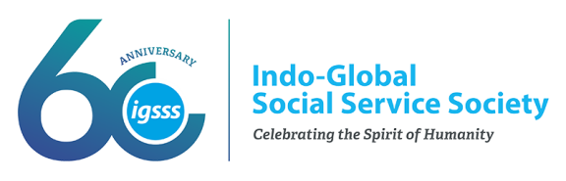

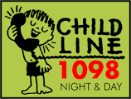
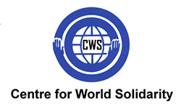

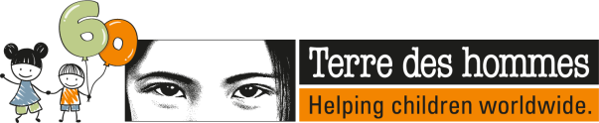

ORGANIZATIONS & INDIVIDUALS
●RAJASTHAN MAITRI SANGH
●Inner Wheel Club of Jamshedpur
●Loyola Alumni Association
●Lions Club of Jamshedpur
●Taruben Gandhi
●SandhyaMurarka
● Jain Samaj
● Rotery
● Dr.NirmalaSukla
● Maa van Vasini Samiti
● Red Cross society
● Prayas

● Rotery

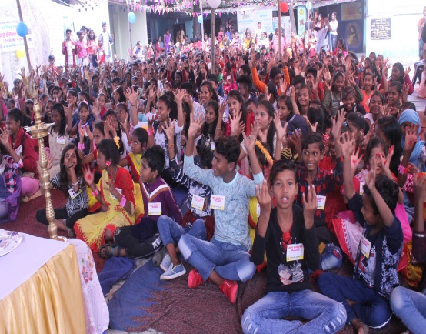

CHILD RIGTHTS

Right
To
Participation
Right
To
Survival
Right
To
Protection
Right
To
Participation

25 slums of Sonari & Kadma
CHILD RIGHTS & YOU
Bal Adhikar Pariyojna

Project Title: Bal Adhikar Pariyojana
Support Organization: Child Rights & You
Project Duration: April 20 to Dec 20
Overview of the Project: CRY - Child Rights and You is an Indian non-governmental organization (NGO) that works towards ensuring children’s' rights. CRY addresses children’s critical needs by working with parents, teachers, Anganwadi workers, communities, district and state-level governments, as well as the children, themselves. The organization focuses on changing behaviours and practices at the grassroots level and influencing public policy at a systemic level, thus creating an ecosystem where children are the nation’s priority.
Goal: To establish rights for slum children in the operational area through intervention at all appropriate level
Objective: To ensure 100% enrollment and retention of children of age group 6-14 and girls age group of 15 to 18 yrs.
Target Group: 6- 18 yrs children and their Family and Community
Location of Project: 25 slums of Kadma and Sonari, Jamshedpur
Major Activities:
- Meeting with Children collective
- Identify irregular & Drop out children in age group 6- 18 yrs
- Regularization and re enrollment of irregulars & drop out children
- Track all children and maintain data base of children through MIS
- Regular Mapping & monitoring of Drop out and Child Labour
- Life Skill session with children in Age group 10-18yrs
- Linking children with schemes and entitlement
- Presenting status of their family (post Covid 19) to Dist. Labour Dept., Rationing Dept., CHILDLINE, CWC etc. for link them to diff. govt. schemes
- Taking support of Govt. Authority towards prevention and stopping Child Marriage
- CRECHE – PALNAGHAR

Achievement:
- Total Bal Sangathan- 29
- Total Members in Bal Sangathan- 541 (M-207, F-334)
- Total no. of Children Leaders- 89 (M-25, F-64)
- Total Children in School:- 6-14yrs- 3961 (2007 M,1954 F), 15-18yrs- 886 (421 M,465 F)
- Drop Out Identify & Enrolled in age group 6-14yrs-: Identify 65 (42 M,23 F) & Enrolled 15 (10 M,05 F)
- Drop Out Identify & Enrolled in age group 15-18yrs-: Identify 47 (25 M,22 F) & Enrolled 02 (01 M,01 F)
- Child Labour Identify & Enrolled in age group 6-14 yrs- Identify 27 (18 M, 09 F) & Enrolled-13 (06 M,07 F)
- Child Labour Identify in age group 15-18yrs-05 (03 M, 02 M)
- Total number of child marriages averted-56 (18 M,38 F) Child marriages averted & 06 child marriages are stopped
- Percentage of cases reported (from operational areas) disposed of from CWCs and Child Line- 43 cases reported and disposed
- Children Passed in Matriculation- 108 (42 M,66 F) Out of 116 (46 M,70 F)
- Children Passed in Intermediate- 34 (11 M,23 F) Out of 38 (14 M, 24 F)
- Proportion of families with vulnerable children linked with social protection schemes-Aayushmaan- 20 families, Labour card- 12 families, Sponsorship (govt.)- 13 (7 M,6 F), Sponsorship (Pvt)- 02M, Mukhya mantra Sukanya Yojna- 63 girls
Meeting with Bal Sanghathan and Bal Sansad

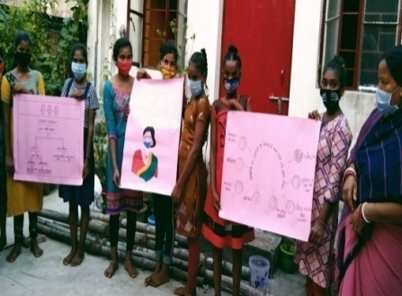
To identify drop – out and irregular children up to 6 -18 years of age a meeting was held with all the children's organizations formed in the settlements with the aim of identifying drop-out and irregular children from the school up to 6-18 years of age in 23 slums (habitations) of Kadma and Sonari, Jamshedpur area. Since the meeting was organized keeping in mind the Corona period and its guidelines.Due to the closure of the school for Corona, it has been difficult to extract information about drop-out and irregular children. Therefore, the children of the children's group involved in these meetings listed the children of their respective slums who were already drop out before the lock down. In addition, children who dropped out of school during the transit period were also identified. A total of 125 were identified during the meeting.

For children age group of 6-18yrs

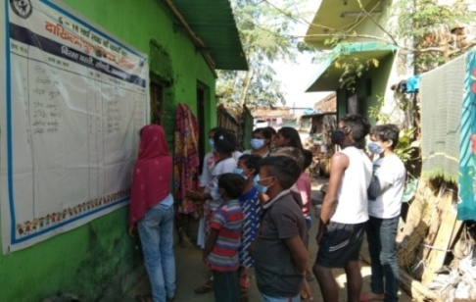
Admission and re-enrolment drive
Due to Corona epidemic and lock down, the school and education process has been completely affected for more than one year. Due to which the number of children left out from admission during drop out, enrollment and transit increased. In view of this situation, admission and re-admission drive was launched.

As a part of the campaign, a banner was made for each slums. In which the name, age, gender, name of the guardian and the date of admission of the children left out of admission during drop out, enrolment and transit were recorded, Which was put on the main walls of all the slums as a campaign. In which the names of the said children were recorded through community initiative.
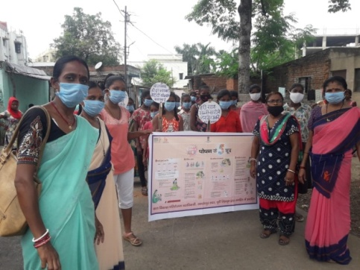
During this, the parents of the identified children also took the responsibility of enrolling their children in the school. After the admission of the identified children, the date of admission of that child will be mentioned in the above banner. This campaign was carried out under the leadership of the children's group of each settlement. And the entire responsibility of this was taken by the children's group. During the campaign, 125 drop out, enrolment and transit children left out from admission were identified through community process. The admission of the identified children will be ensured in the new academic session in April 2021 through community effort. Women and community leaders, Anganwadi workers, teachers etc. participated in the campaign.

COVID Relief Program at 23 Slums of Sonari-kadma (Jamshedpur)
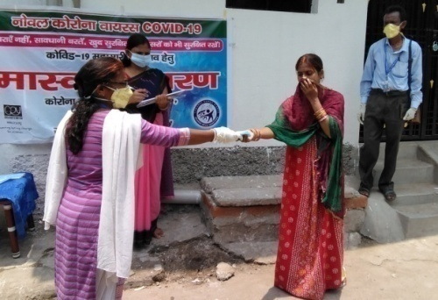
- 1776 dry relief ration packets were distributed containing rice or chura, dal, potato, mustard oil, salt, soaps, etc. among the families of slum area of Sonari and Kadma supported by Alumuni, Loyola School and Maa Vanvasini Seva Samiti in joint collaboration.
- 35,000 masks were distributed in different govt. department, private institutions, children home, schools, RBC camp school, govt. officials, individuals, slum basti in and around the operational area of Jamshedpur and people in different programs conducted during the period. Apart from this 800 masks and gloves were distributed among the children and community of the operational area after motivating Loyola Alumuni and Rotary club.
- 160 packets of cooked food (bhat, dal, sabji/khichri) per day were distributed to the neediest people/families of slum area in the month of April and 180 packets of food per day in May and June (distributed for a total of 72 days) by motivating Jain Community.
- 38,705 milk packets for 1860 children between 7 months to 3 years of age along with lactating mothers of operational area were distributed through liaison with DC, East Singhbhum supported by Alumuni and Loyola School, Jamshedpur. Hand gloves were also distributed to 23 AWWs and local volunteers for distribution of milk & biscuits.
- Supplementary nutrition food was distributed for 176 children of age group 1 to 10 yrs by Red Cross Society after motivation of ASES.
- Sanitary pads were distributed to 130 adolescent girls and women of Baba Tilka Majhi basti and Rupnagar slums of Sonari supported by Prayas organization.

FLEXI Grant- Relief & Awareness Programme
CHHAYANAGAR
&
CHANDDINAGAR

Project Title: Flexi Grant
Support Organization: Child Rights & You
Project Duration: Oct 20 to Dec 20
Overview of the Project: As per proverb “One gets new experience from every incident”. People learnt something different from Covid 19 pandemic situation. They face many difficulties and challenges from Covid 19 and situation became under control but not yet ended. Relief and awareness programs have both become a great support to the families of this area benefitting children during the situation. While on one hand, some relaxation has been given by the government, due to which people are gathering everywhere and government guidelines are being ignored. Hence there must be regular initiatives to alert people and create awareness.
Goal: To establish rights for slum children in the operational area through intervention at all appropriate levels
Objective: To establish rights of the children and Covid relief activity
Target Group: 6- 18 yrs children and their Family, Community,
Location of Project: Chhayanagar and Chandinagar, Jamshedpur
Major Activities:
- Regular Meeting with Children
- Identify irregular & Drop out children in age group 6- 18 yrs
- Regularization and re enrollment of irregulars & drop out children
- Basti Sanitization Programme
- Sanitization kit distribution for adolescent girls
- Family Awareness on COVID – 19 through children
- Community Awareness through poster campaign
- Distribution of Relief item (food Pkt)
Achievement:
- Covered more than 200 children and youth group in Basti Sensitization programme
- Distributed 100 sanitization kit to adolescent girls

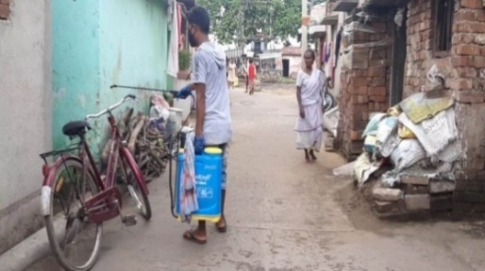
Basti Sanitization programme
Basti sanitization campaign was undertaken in these two slums by conducting bleaching spray through involving youth volunteers to support the programme. Apart from this ‘CHILDLINE Se Dosti’ programme was conducted by CHILDLINE team by tying-up CHILDLINE se dosti wrist band to different stakeholders along with children. Team covered more than 200 children and youth group during this program which has very positive response of the people of this area towards awareness.
Sanitization kit distribution for adolescent girls
Under this programme sanitization kits like; sanitary pad, mask, hand wash, sanitizer, soap and bags in which Covid awareness matters printed on it were distributed among 100 adolescent girls of these two slums of age 13-20 years. Beneficiaries (adolescent girls) were selected via door to door visit before conducting of the program. The distribution was conducted by 10 adolescents of each group at different places to avoid mass gathering as per government guidelines and the knowledge were transferred to them.
Family Awareness through Children
Family awareness programme was organized in campaign mode where 75 interested children (M-19, F-56) became a part of making drawings on Covid 19 to whom drawing materials like; drawing sheet, pencil, eraser, sharpener and color crayons were distributed to each of them through visiting door to door. During this programme they were explained about what to draw at their homes which were collected from them after 2 days. They drew very nice paintings in which were pasted on their doors and walls by them for awareness building. All of them were honored with the gift packets of sanitization kits and education materials like; sanitizers, mask, hand wash, copy and pen. The campaign has very positive impact to the people as well as children.
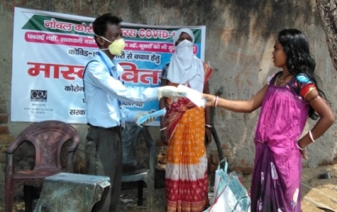
Community Awareness through poster campaign
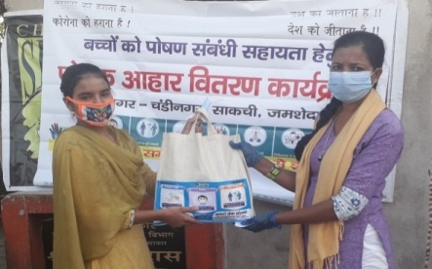
During this programme posters were printed out prescribed by Ayush Mantralaya, Govt. of India containing general awareness to highlight Ayurvedic Immunity Promoting measures and booster-up during any symptoms are shown as stated for covid 19 like; dry cough and sore throat and severe acute respiratory syndrome.Posters were pasted on different community walls for people’s awareness by the members of BalSangathan, women leaders and youth group of the basti which has good impact in the community.
Distribution of Nutrition food packets
Nutrition food packet materials including chana, gud, dal, peanuts and nutrilla (soyabean) including bags were distributed as awareness kit among 80 Bal Sangathan leaders including vulnerable children (drop-out, child labour) in these two slums. It has resulted good impact among nutrition of the children in the adverse situation prevailed in this area. Due to corona pandemic their economic situations were critical.
8 Block (Baharagora, Bodam, Chakulia, Dumuria, Golmuri cum Jugsalai, Gurabandha, Patamda&Potka)

CHILDLINE COLLABORATIVE ORGANIZATION (COLLAB)-1098,

Project Title: District CHILDLINE (COLLAB)-1098 EMERGENCY SERVICES
Support Organization: CHILDLINE INDIA FOUNDATION
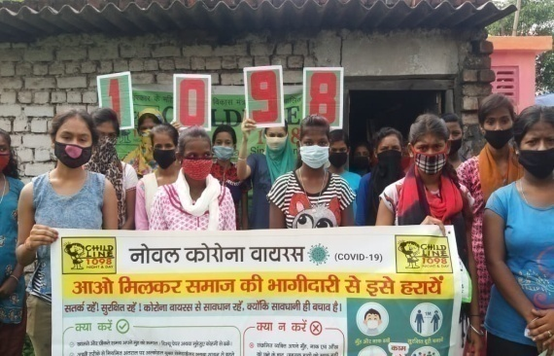
Project Duration: Feb 2016 to Continue
Overview of the Project: CHILDLINE is India’s first 24-hours toll free emergency phone outreach service for children in need of care and protection linking them to long–term service for their care and rehabilitation. Any child and concerned adult can call 1098 and access the CHILDLINE service any time of the day or night.CHILDLINE has the vision to build a Child-friendly nation that guarantees the rights and protection of all children.
Goal: To reach out to every child in need and protection ensure their rights and protection through connect, catalyze, collaborate and communicate to build a child friendly nation.
Objective:The major objective of CHILDLINE is to reach out to every child in need of care and protection by responding to emergencies on 1098. To create awareness about CHILDLINE 1098 amongst every Indian child as a reliable source in need is also another objective of CHILDLINE. This program also advocates services for children those are inaccessible or non- existent.
Target Group: 0-18 years of children
Location of Project: 8 Block (Baharagora, Bodam, Chakulia, Dumuria, Golmuri cum Jugsalai, Gurabandha, Patamda&Potka)
Major Activities:
- Awareness meeting with different stake-holders like Chowkidar, PRI member, ICDS, School teachers and children, ICDS workers, SHG Group, Community member, BRC/CRC member volunteer and children etc for child rights and child protection issues.
- Open House Programme to give platform to the children to express their problems and issues.
- Display of Wall writing and boards and IEC materials for the awareness generation.
- Day to Day Outreach Programme
- Phone testing for the better connectivity of the 1098 Toll free number
- Special Programme and day’s celebration like National Girl Child Day, Human Rights Day, Environment Day, Independence Day etc.
- COVID relief Activity

Achievement:
- Conducted 121 meeting withSchool teachers and children, ICDS workers, SHG members, Community, BRC/CRC, Gram Panchayat, Chowkiadar, Children Group and volunteers for awareness on child rights and child protection issues.
- Total 2328 Hours of outreach conducted and received 142 case from outreach
- Conducted 6 open house meeting with children in different areas
- Conducted 223 phone testing
- Awareness on Poshan Maah
- Conducted various special dates like International Children Safety Day, World environment Day, World Day against child labour, Gandhi Jayanti, World girl child day, World Human Rights Day, Republic Day
- Conducted awarenessprograms on COVID–19 with children and community.Drawing competition with children on COVID–19 activity.
- Slum Sanitization, cleannessactivity and guiding Children and adult to maintain Social distancing at Crowded Place and wearing mask from protection of COVID-19 virus.
- EssayCompetition on the occasion of Beti Bachao Beti Padhao.
- Distribution of dry ration, Food packets, Educational Kit, COVID-19 Precaution kit to the School Children with Joint collaboration from Zomato Jamshedpur at Saraswati Gyan Jyoti Adarsh Vidhyalaya, Nirmal Nagar-A, Sonari. On the occasion of their Anniversary.

Case Category | Total Intervened Cases | Assistance Provided
Medical | 20 | 20
Shelter | 62 | 60
Restoration | 12 | 12
Protection from Abuse | 108 | 108
Conflict with law | 00 | 00
Sponsorship | 01 | 01
Child Lost | 28 | 28
Parents asking for help | 0 | 0
Emotional Support & Guidance | 8 | 8
Others | 54 | 51
TOTAL | 293 | 288

CHILDLINE Se Dosti Campaign14th to 20th Nov,

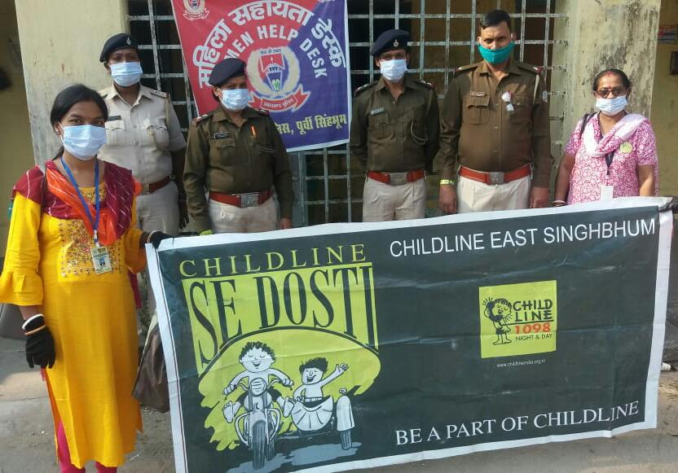
CHILDLINE Se Dosti is a one week programme which starts On 14th Nov to 20th Nov. We went to different place for awareness and tying band to different stakeholders. For this reason we went to different locations. On 14th- Sidhu Kanhu Basti, Near Shiv Mandir, Sonari, Chayanagar & Chandinagar On 2nd day -Mango Bus Stand, Mango, Movement of CHILDLINE Van for awareness Sakchi Gol Chakkar, Bage Basti, Kadma, New Kapali Sonari, Jhabri Basti, Sonari, Janta Basti, Sonari. On 3rd Day- Sonari Police Station, Sakchi Police Station, Sitaramdera Police Station, Golmuri Police Station, Sidgora Police Station, Kadma Police Station. On 4th day -MGM Hospital, Mango, MGM Police Station, Azad Nagr Police Station, Ulidih Police Station, Mango Police Station, Govindpur Police Station, Telco Police Station. On 5th day –Adarsh Seva Sansthan, Sonari, BDO Office Bodam, BDO Office Patamda ,Police Station, Bodam, Police Station Patamda. On 6th day- DC Office-DC Sir-Mr. Suraj Kumar, Children Group of Ram Nagar, Bagbera, Children Group of Babudih. On 20th Nov, 2020- Adarsh Seva Sansthan, Sonari

Resource Organization Meeting

On 18th March 2021 at Mahila Kalyan Samiti, Sundar Nagar, Jamshedpur resource organization meeting has been organized and discussed on the issues like Shelter Home for Girls in our District, Centre Home for Mental Disorder Children, De-addiction Centre for Drug Addicted Children in our District, Increase and Spread the Volunteer of CHILDLINE, lodge FIR on Protection from Abuse (PFA) cases, support and assistant from respective government departments, CCI, NGOs and Stakeholders. In meeting participants given some solution and major outcome came like, It is very necessary that one by one circulars are issued for the agendas of last CAB meeting and we take quick action for that, Every NGO should listed and print their road maps for the identification of Child marriage cases of their areas.

CHILDLINE ADVISORY BOARD Meeting
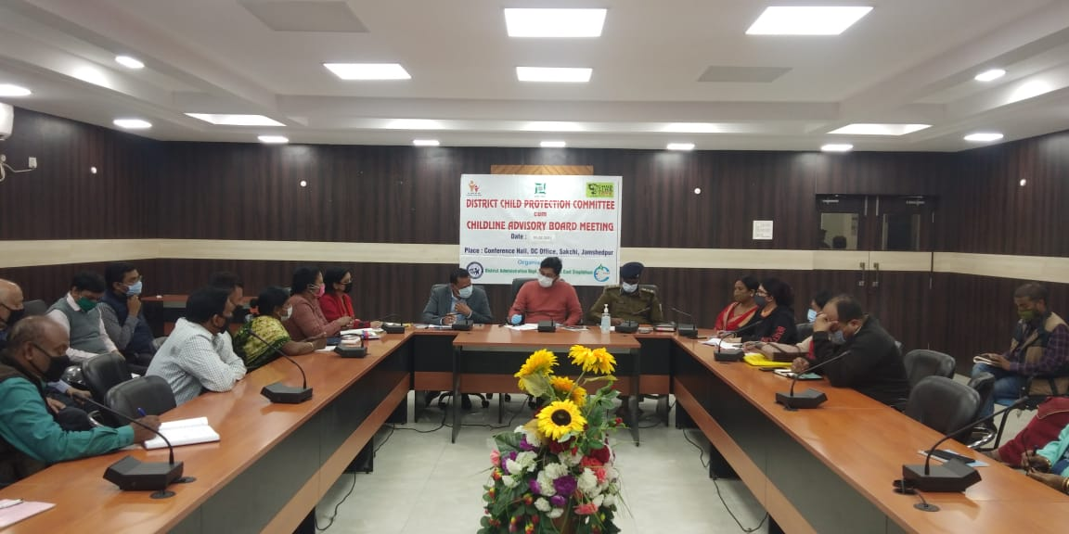
CAB meeting is a major activity or programme is organized by CHILDLINE for smooth function of CHILDLINE in the district. The CHILDLINE Advisory Board is headed by DC and to take all govt. services in one roof. This year CAB meeting organized on 28.09.20 and 5.02.21 at DC conference hall, DC office.

TATANAGAR, ADITYAPUR, GAHMARIYA, SINI& 1 KM PERIPHERY AREA OF TatanagarRAILWAY STATION
RAILWAY CHILDLINE- CHILD HELP DESK/ CHD (COLLAB) -1098,

Project Title: RAILWAY CHILDLINE- CHD (COLLAB) -1098 EMERGENCY SERVICES
Support Organization: CHILDLINE INDIA FOUNDATION
Project Duration: 1st May 2018 to continue
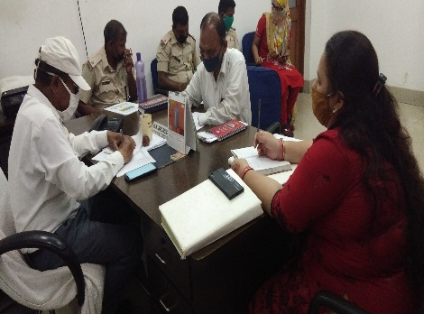
Overview of the Project:CHILDLINE is India’s first 24-hours toll free emergency phone outreach service for children in need of care and protection linking them to long–term service for their care and rehabilitation. Any child and concerned adult can call 1098 and access the CHILDLINE service any time of the day or night. CHILDLINE has the vision to build a Child-friendly nation that guarantees the rights and protection of all children in contact with Railway. Railway CHILDLINE has to deliver child protection Activities at Tatanagar Railway Station
Goal: To ensure care and protection of children in contact with Indian railways.
Objective:The major objective of CHILDLINE is to reach out to every child in need of care and protection by responding to emergencies on 1098. To create awareness about CHILDLINE 1098 amongst every Indian child as a reliable source in need is also another objective of CHILDLINE. This program also advocates services for children those are inaccessible or non- existent.

Target Group: 0-18 years of children
Location of Project: Tatanagar, Adityapur, Gahmaria, Sini & 1 Km Periphery Area of Tatanagar Railway Station
Major Activities:
- CHG (CHILD Help Group) Meeting at Tatanagar station.
- Awareness meeting with different stake-holders like Porter, Vendor, Cleaning staff, Parking staff, Parcel Staff, Children, Teacher, Mother and ICDS workersetc on child rights and child protection Issues.
- Open House Programme to give platform to the children to express their problems and issues.
- Display of Wall writing and boards and IEC materials for the awareness generation.
- Day to Day Outreach Programme in Platform and train.
- Phone testing for the better connectivity of the 1098 Toll free number
- Special Programme and day’s celebration like Hand Wash Day, National Girl child day, CHILDLINE Se Dosti, Drawing competition among children on COVID awareness, Child Labour Day, Yoga Day Celebration, World Daughter’s day, Dan Utsav and International Girl Child Day etc. for awareness generation.
- COVID relief Activity
Achievement:
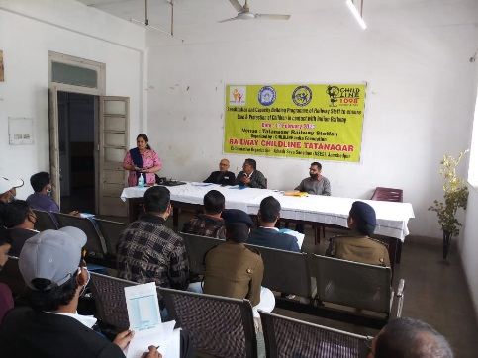
Training cum Meeting with Railway Stakeholders- 17.02.21 & 18.02.21-
Two days training programme has been organised at Tatanagar station on Juvenile Justice Act 2015 and ‘Understanding the role of Stakeholders as per Revised SOP for Railways to Dy Commercial Inspector, TTEs, Guards, GRP Staff, RPF staff and Railway CHILDLINE Tatanagar Team. Total 67 participants learned these issues.

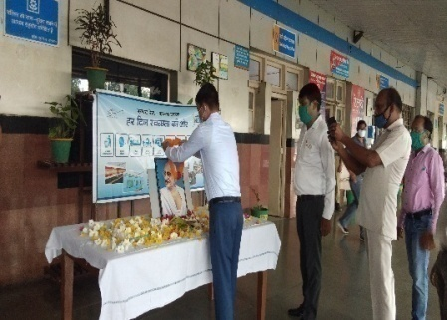
Celebration of Gandhi Jayanti- 2.10.20
A programme organized on the occasion of Gandhi Jayanti with the support of Railway stakeholders at Tatanagar station. The programme started with Sradhanjali to Gandhi Ji Photograph by Mr. Vikas Kumar ARM, Tata. He shared few words on the important of the day and also shared that it is 150th birth anniversary and also remembered his great work in freedom fight. It is very necessary to incorporate his thoughts ideas and teaching in our life to be better human being and it will help in Nation building. Then we donated 500 pieces masks to Railway Authority for COVID-19 precaution.

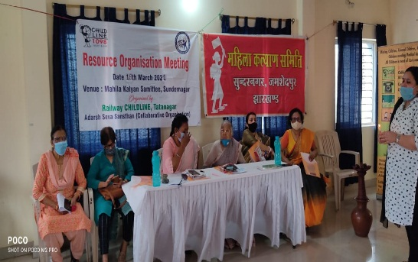
Resource Organisation meeting: 18.03.21
Resource organization meeting has been organized at Mahila Kalyan Samite, Sundernagar for coordination and sensitization of different NGO’s and stakeholders for issues related to child protection.

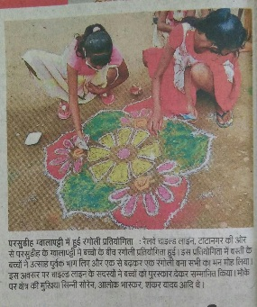
Rangoli Competition- 17.12.20
Arangoli competition has been organized with children group of Gwalapati and total 14 children has been participated in this programme. After competition children were awarded with prize and gifts and encouraged them at the end of the programme chocolates were distributed between them.

Hand wash Day- 15.10.20-
Global hand was day was celebrated at Pradhan tola, Parsudih with children and discussed about the importance of hand wash and also demonstrated 6 steps of hand wash. Sanitation kit was provided to them.
CHILDLINE Se Dosti- 14.11.20 to 20.11.20
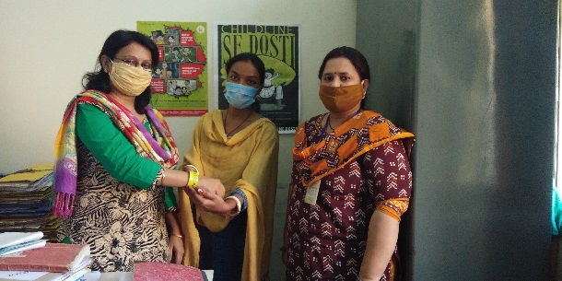
14.11.20 One day Programme has been organized on the occasion of children day for the inauguration ceremony of CHILDLINE Se Dosti with children group of Muigutu. 15.11.20 A program has been organized with children group of Makdampur children’s day celebrated and also explain the reason for celebrating Dosti week with 16 children. 16.11.20 Canopy activity has been organized at Tatanagar station and Dosti Band tied up to GRP, Cleaning staff, passenger.17.11.20 Awareness and CHILDLINE Se Dosti programme done at Sadar Hospital and tied dosti band to various stakeholders like Doctors, ANM, Nurses, Counselors and other hospital staff etc. 18.11.20 Campaign started in Gahmariya, Adityapur and Kadara station, our team has tied band to various stakeholder’s in Gahmariya, Adityapur and Kadara station like Station Master, Enquiry staff, RPF, GRP, TTE, Cleaning Staff, Auto Driver, Vendors and Passengers etc. We visited Bistupur Police station tied dosti band to CWPO, station In-charge and other police personnel’s and they gave their consent as “I am a CHILLDINE Dost”. Also dosti activity done at Tatanagar station and band tied up to Venders, Cooliee, RPF, Auto Driver and Dy SS Commercial.19.11.20 we tied dosti band to Ms. Chanchal Kumari (DCPO) and she gave her consent as CHILDLINE se Dost. A program has been organized with children group of Makdampur children’s day celebrated and also explain the reason for celebrating Dosti week with 16 children. 20.11.20 we (Collab & Railway- CHILDLINE) organized joint closing ceremony of “CHILDLINE se Dosti campaign” with the children in Adarsh Seva Sansthan, Sonari, Jharkhand and their parents by tying dosti band, also made children aware about 1098- CHILDLINE. Children have shown their various skills like, dancing, singing, acting and recieving poem in the cultural programme organized by them.

CHANGE ENABLED:
- CHILDLINE team has conducted Total 4147 person hours of outreach (Day & night)
- Aware total 37578 persons about CHILDLINE Services
- 128 cases intervened by Railway CHILDLINE team from April 2020 to Mar. 2021,
- 114 cases have been received from outreach (CWC, DCPO, P.S., RPF, GRP & others).
- 65 Volunteers of CHILDLINE from different stakeholders.
- 128 Children were restored or sent to their family by us.

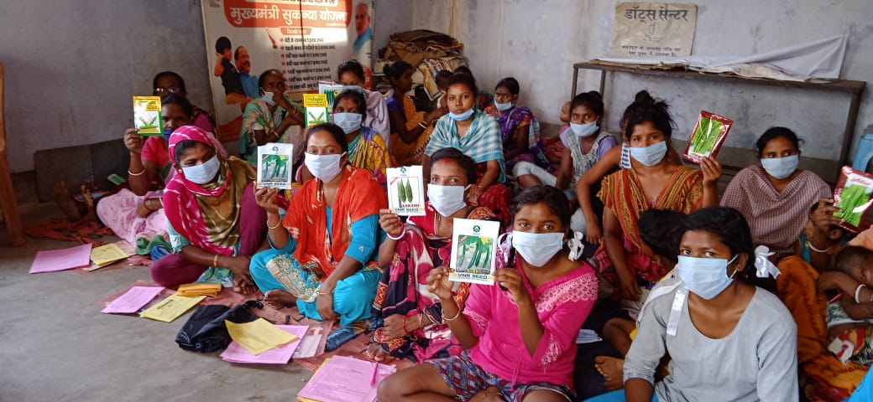
Empowering Women
&
Adolescent

Improving Social& Economic Empowerment of Women by changing Nutrition status, Health and Hygiene practice of women and children

Project Title: Improving Social & Economic Empowerment of women
Support Organization: CWS (Center for World Solidarity)
Project Duration: 1st April 2020 – 30th September 2020
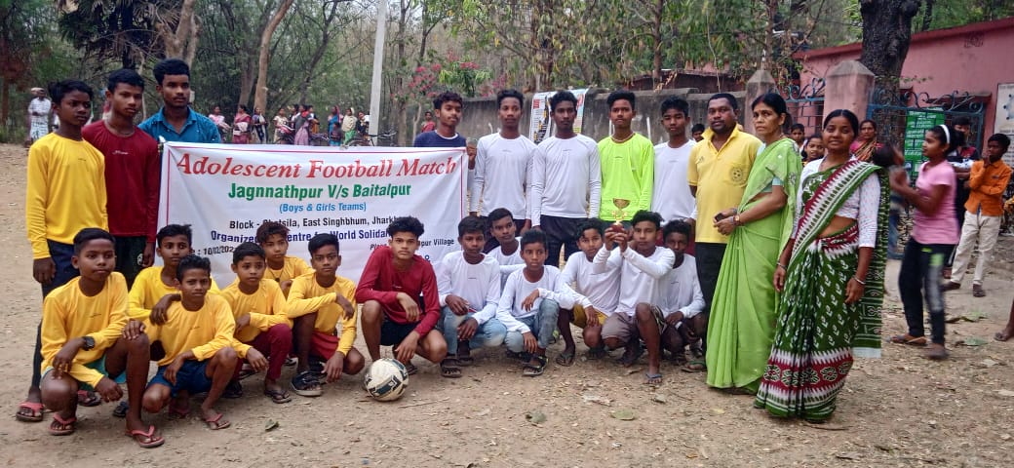
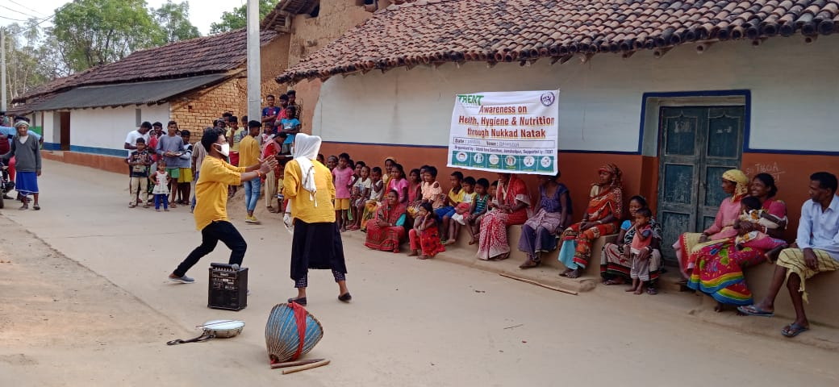
Overview of the Project:Centre for World Solidarity (CWS) has been actively involved in development work in India since 1960s with the vision of " Emergence of society of resilient, inter-dependent, small communities, vibrant with the consciousness of their rights and duties and sensitive to the rights of dalits, tribal and minorities to women rights generally and to gender equality to the rights of children and to eco-friendly development process that cohere with the rights of these sections". This project aims to improve the status of women and children by empowering them and giving them right opportunity to make their life better by adopting new techniques of farming. For reaching technique this objective livestock farming and vegetable nursery training has been given. Also hand holding them on different government schemes. Regularizing their saving habits in Self Help Group (SHG).
Goal: To Improve Nutrition, Health and Hygiene Practice of women and children up to age group of 15 years.
Objective: Improving Social & Economic Empowerment of Women by changing Nutrition status, Health and Hygiene practice of women and children
Target Group: Women and Children Up to 16 yrs. of age
Location of Project: Jagnnathpur and Baitalpur Villages of Ghatsila Block of East Singhnhum
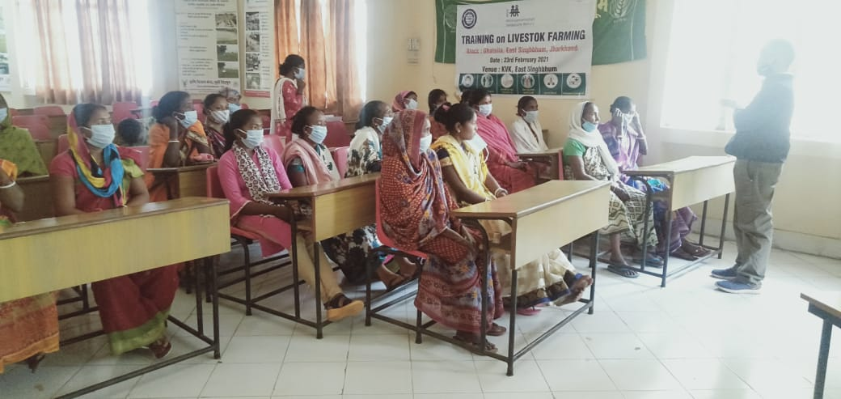
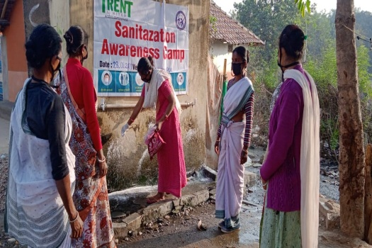
Major Activities:
- Quiz / Drawing competition with School children and Adolescents:
- Capacity Building training on health, hygiene and nutrition issues
- Promotion and strengthening though Football match
- Regular SHG Meeting with 29 group
- Training on vegetable nursery raising followed by exposure visit
- Training on Livestock farming
- Input support for selected 20 Farmers
- Training for the awareness creation on the government schemes
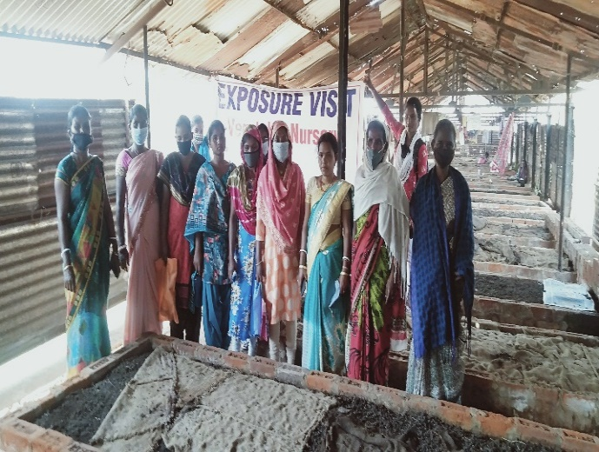
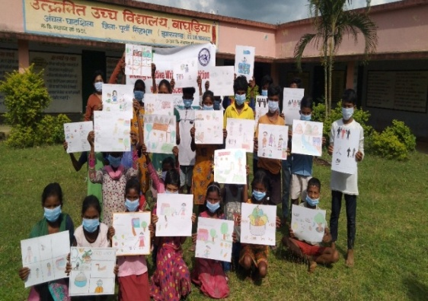
Achievement:
- 115 women farmers have improved kitchen garden/vegetable nursery and livestock farming. This increased the income of their families through continuous selling of agriculture products and consuming healthy foods by their family. They became aware about good practice of health, hygiene and nutrition.
- 60 school children (including BalSansad and football team of girls &boys) became aware on health, hygiene and nutrition. They are conducting activities and sessions in their classes, participating in drawing competition, quiz competition and football tournament.
- Linkage of 26 SHGs with different institutions and government schemes.
- 8 SHG women's making of mask for villagers and distribution all family. Than 8 SHG women income generate Rs. 2500/-.
- Village women have good impact at different level of support from the project resulting they are working for vegetable nursery and livestock farming as habit of saving which is a source of income and women empowerment.
- 60 village School children a provided mass and sanitizer.
- 40 poor women distribution Dry Ration Items.

Improving nutritional status and entitlement realization by Empowering Adolescent and Young Women

Project Title: Improving Social & Economic Empowerment of women
Support Organization: Trent Ltd (Star & Diya)
Project Duration: 1st July 2020 – 31st March 2021
Overview of the Project: Trent Limited (portmanteau of Tata Retail Enterprise) is the retail hand of Tata group based out of Mumbai, Maharashtra. Started in 1998, Trent operates Westside, one of the many growing retail chains in India based in Mumbai, and Landmark, a bookstore chain with brick and mortar stores in various locations of India. Trent provides sponsorship for NGO projects in areas of Child Education & Nutrition by providing financial support across locations. This is done through a Diwali and Christmas festival promotions (Star & Diya) initiatives in Westside stores. This programme enables the customers to participate in ‘giving’ by lighting a diya during Diwali, or putting up a star on the Christmas tree during Christmas season; the proceeds of which are routed to select NGOs who are engaged in community work. Through this annual initiative Trent supports the education and nutrition for the children of disadvantaged communities by providing financial assistance in various forms like education and nutrition.
Goal: To improve the health, hygiene and nutrition status of adolescent and young women especially of tribal community.
Objective:
- To improve the health, hygiene and nutrition status of adolescent and young women especially of tribal community.
- To create awareness on the government programme and facilitating towards entitlement realization on health and nutrition issues
- Demonstrate multi- sectoral model of convergence for empowering girls and young women to reduce anemic cases. System strengthening on Adolescents nutritional practices through leveraging different components under Jharkhand Nutrition Mission (JNM)
Target Group: Adolescent of ST/SC and OBC community
Location of Project: Baghuria, Jorisa, Bankati, Handoljuri and Uttar Moubhandar of Ghatsila Block of East Singhnhum
Major Activities:
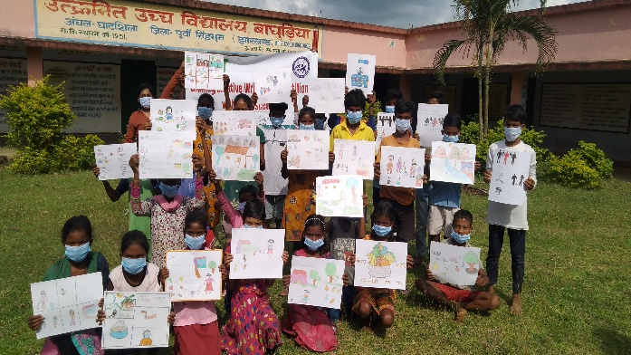
- Quiz / Drawing competition with School children and Adolescents:
- Capacity Building training on health, hygiene and nutrition issues.
- Pictorial wall writing in 10 School.
- Awareness health, hygiene and nutrition security though street play and nukkad natak.
- Organization Nutrition Camp.
- Training for the awareness creation on the government schemes.
- Publication of IEC material.
Achievement:
- 457 school children target panchyat capacitated on the COVID-19, Health & hygiene and nutrition issues.
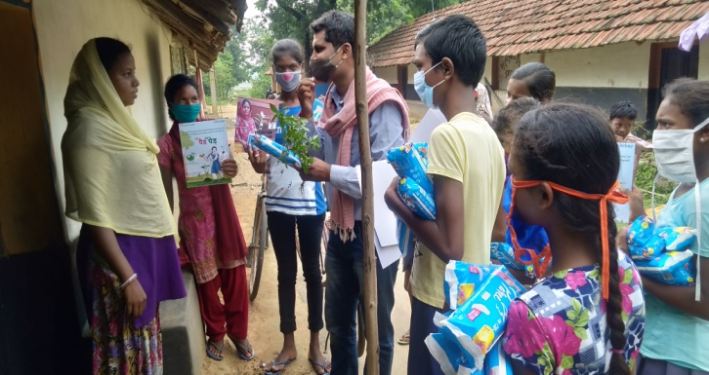
- Pictorial wall painting/writing on Health, hygiene and nutrition have been done in target panchayat 10 Schools: - Primary knowledge on Health & hygiene and nutrition security reached up to 1000 rural children, adolescent, man, women and households.
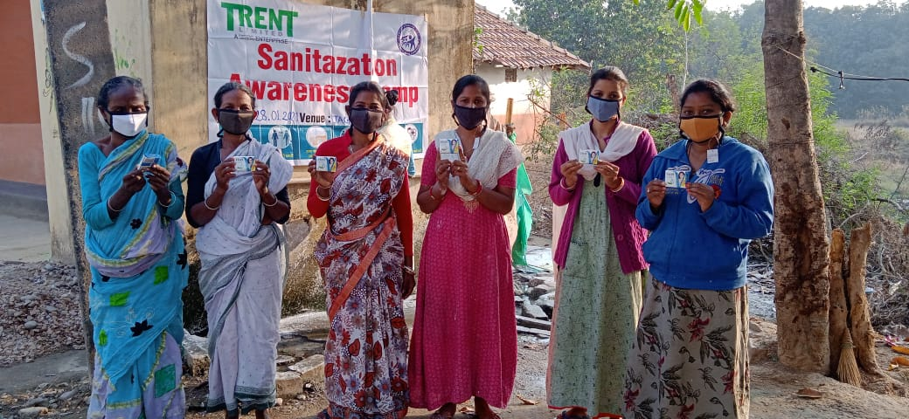
- 60 women's awareness creation on the government program and benefits for them and how they will be eligible for each scheme. They came to know about the program.
- 500 School children a provided mask and sanitizer.
- 5 nos. of organized Nutrition comp Village sanitization campaign conducted bleaching spray through involving SHG’s women adolescent to support the programmer sanitization kits like; mask, hand wash, sanitizer, soap in which ICE awareness matters printed on it were distributed among 300 women and adolescent girls of these three village. Beneficiaries (women) were selected via door to door visit before conducting of the program.
- Training for the awareness creation on the government schemes related with nutrition and livelihood: 60 SHG’s women are aware about government scheme.
- Publication/printing of IEC materials on compilation of Nutrition, Health Hygiene. Were also distributed among 1000 School (Village level) children, adolescent’s girls/boys along with women farmers.

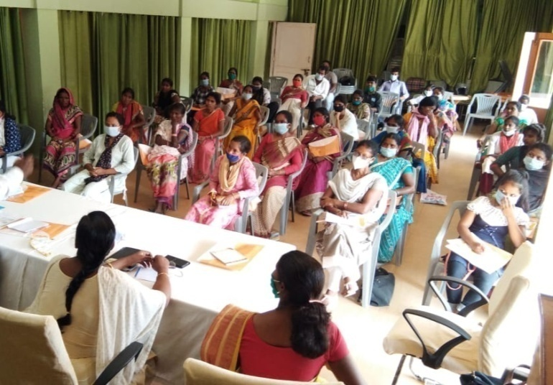

SOCIAL SECURITY
&
ACCESS HOUSING RIGHTS

Jamshedpur, Ranchi, Jharia, Hazaribag, Chaibasa and Chas covering 112 slums

Improved Access to Housing and Basic Civic Amenities along with entitlement realization for various Social Security Schemes for Urban Poor

Project Title: Improved Access to Housing and Basic Civic Amenities
Support Organization: FORD Foundation
Project Duration: 1st July 2020 – 31st March 2021
Overview of the Project: The Ford Foundation is an American private foundation with the mission of advancing human welfare. Ford Foundation's programs have focused on increased under-represented or "minority" group representation in education, science and policy-making. For over eight decades their mission decisively advocates and supports the reduction of poverty and injustice among other values including the maintenance of democratic values, promoting engagement with other nations, and sustaining human progress and achievement at home and abroad.
Goal: to improved Access to Housing and basic civic Amenities along with entitlement and social security.
Objective:
- To action to end poverty, protect the planet and ensure that all people enjoy peace and prosperity by 2030
- to access the government schemes and benefits entitlement
- to work for the slum development through information regarding Govt. scheme
- to make the people capable enough to fight for their own rights
Target Group: Slum Community
Location of Project: Jamshedpur, Ranchi, Jharia, Hazaribag, Chaibasa and Chas covering 112 slums
Major Activities
Institutional Capacity Development:
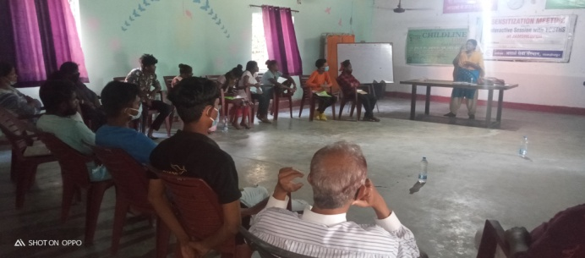
Capacity Development of staff as well as members was organized covering details about Sustainable Development Goals (SDGs) and Master Plan. It’s must and also need of the hour for all of us to know about these goals as our work is interlinked with these goals. Also, most of the schemes / mission of the government is/will be linked to these goals only. It was shared with participants that Sustainable Development Goals (SDGs), also known as the Global Goals, were adopted by all United Nations Member States in 2015 as a universal call to action to end poverty, protect the planet and ensure that all people enjoy peace and prosperity by 2030. The 17 SDGs are integrated—that is, they recognize that action in one area will affect outcomes in others, and that development must balance social, economic and environmental sustainability. As the lead UN development agency, UNDP is well-placed to help implement the Goals through our work in some 170 countries and territories. All the 17 Goals were discussed keeping in mind the nodal ministry responsible for respective SDGs followed by centrally sponsored schemes, related intervention (by government in the form of scheme/ mission), targets and other concerned ministries/departments responsible for implementation. There was discussion with regard to Master plan as to which color depicts what, what is existing and proposed land use, whom to approach in case we feel if there is any violation in Master Plan.
Capacity development of community leaders & CBO's at city level
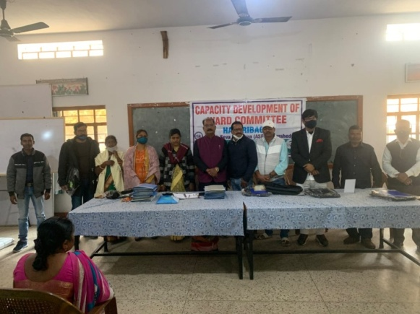
Majority of slum dwellers are engaged with unorganized/informal sector. Due to lack of information and awareness the unorganized workers are vulnerable to employment insecurity, low wages, works’ hazards, gender harassment and even insecure of their lives. They are even unable to access the government schemes and benefits entitlement to them. As there are schemes being run by Department of Labour, Employment and Training, Government of Jharkhand (GoJ) for unorganized and construction labour, hence we shared schemes in detail, about the registration process and benefits available in the scheme. We insisted on them to register in these schemes with the support of our team member and alternatively they must visit labour department of their city. Participate in the camp being organized by us as well as department. There were discussions in detail with regard to Master Plan. How Master plan is prepared and which depicts what and what is the meaning of land use i.e. proposed and existing land use. Whom to approach if there is violation in land use and how details can be gathered through filing RTI.
Sensitization cum interactive sessions with Youths:
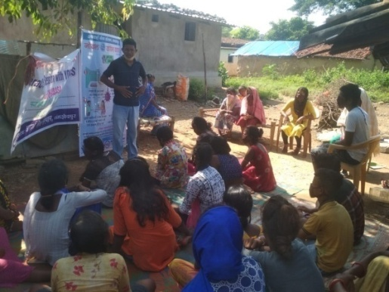
Due to pandemic COVID-19, we have decided to organize this program adhering to the norms and guidelines of the government. Main objective of the program was to gather the details about Impact and which all changes happened during and post COVID-19on education system followed by challenges students are facing. Major concern among the students was attending of online classes as it is not feasible for parents to provide smartphone to each of their children. Also, certain behavioral changes happened among parents as well as children / youths. We asked them to remember SMS (Maintaining Social Distancing, Wearing Mask and Use of sanitizer/soap regularly) and told them to share the concept of SMS with others too. We had discussion about Sustainable Development Goals (SDGs) which are directly or indirectly linked to ensuring education and various social security schemes.We had a discussion about the “Sustainable Development Goal”. The United Nations has challenged 195 nations to address the needs of its people, children, and families in the Sustainable Development Goals Global Movement.The Goals include 17 key elements to improve health, education, the environments, gender equity, and pay wages, by the year 2030
State Level Meeting with Joint Bastee Committee
Adarsh Seva Sansthan Sonari, Jamshedpur had organized a 2 days state Level Meeting of Joint basti committee. Objective of the meeting was well described by Mrs. Lakhi Das (Project Director, ASES) she said that while working for the urban poor awareness among the people should be in the first priority. This awareness would create the sense of unity among the people. In order to work for the slum development information regarding Govt. scheme is the most important. Our aim is to make the people capable enough to fight for their own rights without any fears to develop capacity among the basti leaders, to raise their problem to concerned authority in proper way
Capacity development of Ward Committee for understanding the conceptual framework of slum redevelopment, resettlement and up gradation in planning process
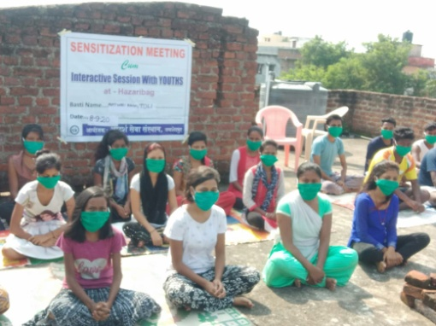
This program was organised in four cities namely Ranchi, Dhanbad, Hazaribag and Chaibasa Most of the urban local bodies in Jharkhand have not yet formed ward committee. We invited ward parshad along with people from diversified segment in the program being organized by us and some cities ward parshad participated in the program too. We focus on various components of Ward Committee such as formation, functions, and work in detail. Had discussed regarding mohalla sabha and subcommittee. Ward parshad ensured to raise this concern in the board meeting which is held at Municipal office. Jharkhand Municipal Act 2011 also talks about formation of ward committee and accordingly we made people aware and sensitize about main theme of 74thAmendment Act which says that Planning for the ward must be from bottom to top which means planning for ward must be prepared by community people with the support and in presence of ward parshad and departmental officials. Invitee letter must be given by ward people to these officials when meeting is planned and signed minutes of the meeting to be shared with all for perusal and necessitate action. During the meeting, basti people shared problems of basti related to basic civic amenities and were asked to submit demand letter for the same to ward parshad. This will ensure Participatory rights by basti representative for making development plan for the ward as per the guidelines laid down in74th Amendment of the constitution of India.
Sensitization cum networking meeting with all significant stakeholders & Civil Society
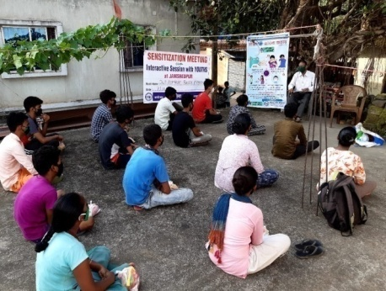
We have been working with urban poor of six cities since last ten long years and now support for the project will be over, hence we planned for meeting with basti representative along civil society. Purpose was to exchange of views on the ways to move forward and accordingly plan for future course of action regarding sustainability. Team will not be able to meet them regularly instead will meet them at frequent intervals and that too onus is on basti representative too. We aware and sensitize basti people in detail about schemes of labour department and insisted them to positively register for it.
Dry ration Distribution in view of COVID-19
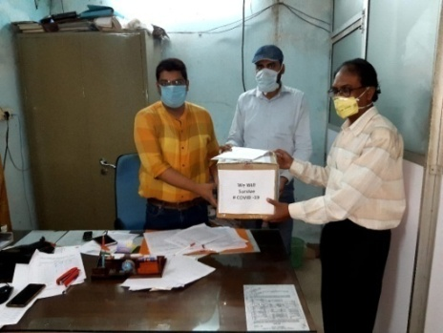
During the year, whole world came across new challenge of pandemic COVID 19. We too supported 2,073 families with relief items consisting of rice, pulses, jaggery, gram, chura, mustard oil, soap. Since it’s not possible for us to reach to each and every household of intervention basti due to limited financial resources, hence beneficiaries were selected on the basis of certain criteria which were decided with the consent of respective city Joint Basti Committee representative.

8th February 2020 | Ranchi
9th February 2020 | Hazaribag

Achievements:
● 334 community members have been made strengthened and capacitated about various schemes/ mission like PMAY (Pradhan Mantri Awas Yojana-Housing for All), SBM (Swachh Bharat Mission), AMRUT ( for water supply), electricity and various social security schemes followed by legal perspective by DLSA ( District legal Services Authority) thereby ensuring active participation in implementation process by pioneers of community. Youths and basti leaders were aware and sensitize with regard to fundamental rights and how to respond to forced eviction.
● 262 basti meeting and 20 Joint basti committee meetings with all CBOs and basti leaders were held during the year.
● We were able to support 2,073 families with relief items consisting of rice, pulses, jaggery, gram, chura, mustard oil, soap during pandemic COVID-19.
● Capacity development of ward committee, this was done for making basti people aware and sensitize about concept of 74th Constitution Amendment Act, 1992. During Mohalla Sabha shared in detail about roles and responsibilities of Local Self Government in Urban areas and mandatorily formation of ward committee in all municipal body.
● As regards to demonstrated improvement of basic services, 33 slums made open defecation free (ODF); electricity connection to 482 households; water supply to 844 families
● 272 students and 14 professors comprising of 3 colleges sensitized on the roles and responsibilities of urban poor, thereby changing their own behavior and attitudes towards the urban poor that they are city makers and not encroachers.
● Rehabilitation of 1 slum (Ghanwadih) of Jharia, Dhanbad under Jharia Rehabilitation and Development Authority (JRDA) scheme of BCCL.
● 436 people got benefit of labour department scheme under unorganized and construction labour
● Organized72 NukkadNatak shows and NukadSabha highlighting schemes of government including 74th Amendment Act, for ensuring participation of people in planning process of government. Since assembly elections were held in Jharkhand, hence Voter election awareness was done through nukadnaktakand aware people that each single vote counts

Jamshedpur, Ranchi, Jharia, Hazaribag, Chaibasa and Chas covering 112 slums

Improved Access to Housing and Basic Civic Amenities along with entitlement realization for various Social Security Schemes for Urban Poor

Project Title: SATAT SHEHAR-3.0
Support Organization: IGSSS
Project Duration: April 20 to Dec 20
Overview of the Project: The IGSSS (Indo – Global Social Service Society is a Non government organization it works towards the development capacity building and enlightenment of the vulnerable communities.
Goal: The quality of life of urban poor and informal sector workers has been enhanced by the active participation of community based coalitions in urban governance, for securing their residential and livelihood rights, through policy engagement at city, state and national levels
Objective:
- Meetings with community collectives (formation of collectives/SHGs/Youth groups).
- Awareness drive on entitlements and role & responsibilities of department.
- Initiatives undertaking to access basic pro poor services in the settlement (Vulnerability Mapping)
- Sensitization events on slum issues.
- Regular camps on training of making of legal entitlements (i.e. Voter ID ,PAN Card , UID ,Bank A/C and other)
- focuses on advocacy on the informal workers right based issues for realigning the policy and campaigning
Target Group: Slum Community
Location of Project: 16 Urban informal settlement of Jamshedpur (areas- Sonari ,Kadma , Sakchi , Burmamines&Jugsalai) , Jharkhand

Achievement:
- Free checkup camp (COVID -19 Test) at intervention areas– 300 HHs
- JUSCO Electricity connection (legal individual electricity connection)- 90 HHs
- Constructed 300 m long drain- 30 HHs
- Unorganized Labour Card- 63
- MukhyaMantriSukanyaYojana- 06
- out of 9 SHG’s 7 become very active
- 13 drop out cases were enrolled in school at Jamshedpur
- In Jamshedpur, MahilaAarogyaSamitee, MAS was formed and functioned. Due to this 250 HHs became benefitted
- 321 persons received unorganized labour card in Jamshedpur
- Labour card claims were allotted to 6 HHs in Jamshedpur
- 60 HHs from Jamshedpur received individual household latrine (IHL) through SBM
- 66 HHs were received LPG cylinder under UjjwalaYojona in Jamshedpur
- 290 HHs were served with slum cleanliness measures by the allocations to MAS
- 7 Individual HH latrines & 2 community toilets were constructed converging Swaccha Bharat Mission. The community toilets are regular in use for 115 HHs
- 1 PCC road was constructed which is in regular access to 103 HHs
Major Activities
Capacity building training of collectives
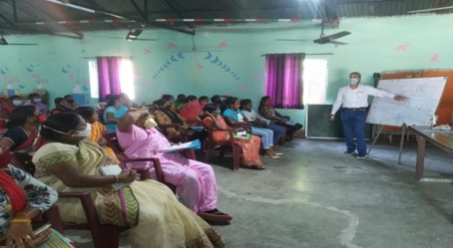
Training was organized for capacity building of CBOs, SGHs, and Youth leaders on DAY-NULM, PMAY at different settlements of the slums. Discussed about govt run programme for the urban poor, DAY-NULM (Deendayal Aantodaya Yojna – National urban livelihood mission) and its verticals “SHG (Shelf help group), SEP (Self Employment Program), ESI & P (Employment through skills training and placement), SUH (Shelter for Urban homeless), SUSV (Support to urban street vendor), SMID (Social Mobilization and institution development. The main mission of this vertical is form groups as well as boost up and improve economic support so that they will start sitting together to share their ideas, issues and starts savings. In ESI & P (Employment through skills training and placement), is to link beneficiaries from 18 Yrs – 40 Yrs with job by providing skill development trainings in different streams with certificate and job guarantee. Shelter for Urban homeless mission is to provide shelter to homeless people.

Meeting with community collectives
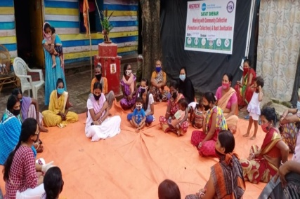
Meeting with community collectives we organize in different slums of project area like Chandi Nagar, Chayanagar and Janta
Basti to interact with identified active leaders and members.
The objective of the meeting to aware community about importance of basti committee, SHGs, Groups and CBOs their roles in basti development and discussed about the benefits of formation of Shelf help group (SHGs). They discussed about the importance of saving in bank and related government scheme for SHG. Every slum facing problem of sanitization as well as required authenticated information for immunity booster hence we provide them demo session for preparing kadha, number of times of uses, regular use of warm water, right way of wearing mask, regular uses of mask etc

Domestic workers federation meeting
A meeting organised with domestic workers to discuss their issues and what are the govt. norms and facility for them. They discussed on low wages of domestic workers in Jamshedpur city, whatever step we can take in this liaison part with employer as well as administration. Also discussed about JOB CARD and required documents, information with beneficiaries

Training of youth volunteers on climate change issues- 5.11.20
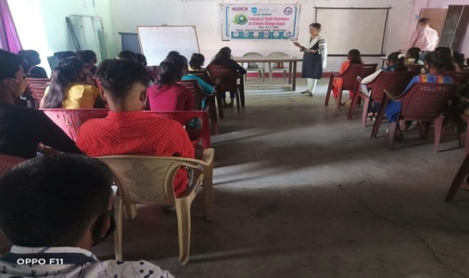
The objective of the training is to learn and make concept of climate – its status past, present and what will be future. Dr .Nirmala Shukla started the session first she share the exact meaning of climate and weather. Climate is the average of weather conditions in an area over a long period. She said at present scenario we are facing huge climate disasters, rapid transformation of weather, humidity, lack of oxygen etc. The rapid growth of climate related disaster and diseases bring severe problems having no cure.
Environment issues nowadays became critical to handle as well as difficult to care the society. Participants have been discussed and raised climate issues related to water pollution, air pollution etc. There is some target areas which is situated on leased land of TATA Steel as well as nearby Iron company (Linde Pvt Ltd) hence we found severe skin diseases among slum dwellers. Participants promised to plant trees in there nearby areas to face this situation.

Facilitation meeting on ward sabha /mohall Sabah (74th constitutional amendment)-
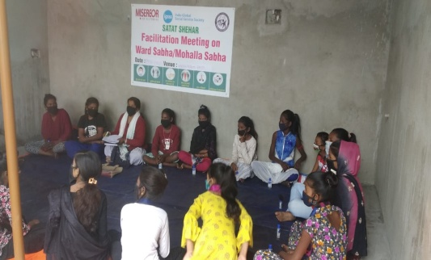
In this Mohalla Sabha youth representatives from five urban informal settlements (target areas) ensure their participation, the program initiated by an introduction session. We have strong discussion with youth representatives / volunteers about urban planning as well as ward sabha structure which is mentioned in 74th constitutional amendment. A discussion done about online study going through schools, we basically discuss and identify the issues facing children and their parents during online studies. After discussion with youth group we identified several issues like creation of gmail, accessing link, creation of id in different portals etc.
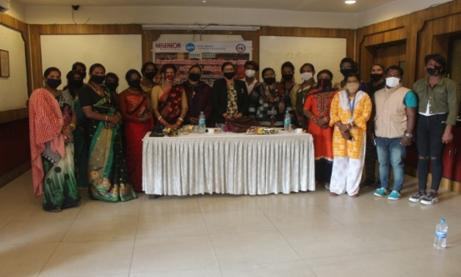
Review workshop with third gender on NALSA Judgment
One day workshop organised at hotel Boulevard on 2.12.20 to review NALSA Judgement on third gender which was announced by Supreme court in the year 2014 which stated that TGs have equal rights as we have in the field of education , visibility in society , respect etc. the workshop main to choke out their problems and fight for them. One of the transgender leaders shared his view that there is no community or an organization came forward to work on the issues of Transgender. There is no visibility of transgender in our state. The community who faces lots of problem and the worst part is no one is there to protect them. Mrs. Mamta Singh (guest and advocate) said that I know the ground reality of TGs community their struggle; I always took stand for their support as well as guide them in legal aspects.

Enabling Inclusive Cities for the Homeless

Project Title: Homeless
Support Organization: IGSSS & OFFER
Project Duration: April 20 to Dec 20
Overview of the Project: The IGSSS (Indo – Global Social Service Society is a Non government organization it works towards the development capacity building and enlightenment of the vulnerable communities.
Goal: The quality of life of urban poor and homeless has been enhanced by the active participation of community based coalitions in urban governance, for securing their residential and livelihood rights, through policy engagement at city, state and national levels
Objective:
- Enhanced capacity and knowledge of identified CSO’s on development and human rights frameworks
- Indentified CSO’s to build strategic alliance with other Civil Society Organisation for the rights of homeless
- To identify leaders from urban homeless community having knowledge on human rights of Urban homeless community
- To empower urban homeless volunteer to engage in addressing development issues.
Target Group: Homeless Community
Location of Project: Shelter homes of Urban informal settlement of Jamshedpur (areas- Sonari, Kadma, Sakchi, Burmamines & Jugsalai), Jharkhand

Major Activities
Outreach Camp at Shelter for Urban Homeless-
outreach camp organized in different shelter homes of Jamshedpur city to aware homeless about the Deendayal Antoday Yojana, Rastriya Sahari Ajiwika mission and to about conditions of shelter homes. Camps were organized at Baridhi, barmamines, Panchwati Nagar and Chandinagar shelter home. Total 170 homeless communities were aware about the social entitlements.
Volunteers training
A meeting was organized with homeless volunteer to aware them what are the provisions for the shelter homes and its managements. Govt schemes and entitlements also discussed. Objective of running shelter home explain what is the necessity of these structure Transgender issues were also discussed in the meeting. At the end of the training volunteers decided to display services of shelter home in every shelter so that everyone will aware about the facility entitled.

Training of trainers (TOT’s) for city Level CSOs
A training programme organized with different NGO’s and discussed about the terms of shelter home facility in it, every shelter home should be 50 to 100 capacity and per perso occupation should be 5 sq. miter. Those organization running shelter homes in Jamshedpur also participated in the meeting and they also explained their issues and challenges and best practices.
Distribution of Dry Ration with nutritional food and safety kit
84 pkts dry ration and safety kit distributed among homeless community during COVID epidemic period as they are unable to get work for their living.

CLEAN JHARKHAND – A way towards pollution free city

Clean Jharkhand is an initiative for cleanliness and towards aware people on health and hygiene. There are 15SafaiMitra (Cleaning staff) who use to collect household garbage from apartments situated in and around Sonari. After collecting garbage it’s disposed at dumping yard which is prescribed by JNAC.
Clean Jharkhand covers 678 HH in three housing apartment. These are as follows –
- 8th phase (HIG) – 98 HH
- 10th phase – 418 HH
- 7th Phase North- -162

Special Thanks
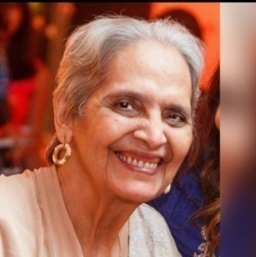
Losing someone can be a difficult thing to go through. True guide are always there for each other in time of happiness and sorrow. Heart full thanks to “Kiran di” for being a pillar in organization whole journey. She is always being some one kind to the people in need.
KIRAN CHAWALA

He believes in making everyone happy, his best quote was “Happiness is when you’re happy because you’ve made someone else happy. He is the best example of success.

GIRIJA SHANKAR JAISWAL

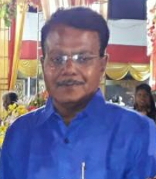
He was good human being. He was excellent in his work and visionary.
ANJAN KUMAR PRADSA

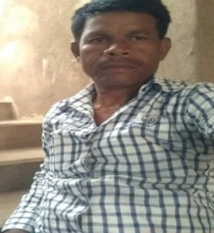
He was profound employee of our organisation and works so hard. We will hold your loving memories in our heart.
BASU MACCHUA

